1.(1.sql) Display names of authors who have participated in writing at least one “business” book. With the provided database instance, the result contains of 9 records, including the TOTAL record as below /

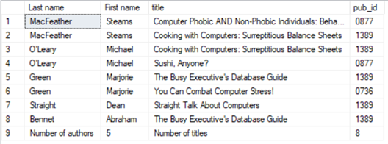

2.(2.sql) List publishers and the number of titles published by each publisher as below Use function row_number() for column [Row]. /

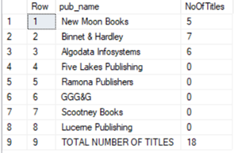

3.(3.sql) List employees hired by the publisher 'Binnet & Hardley' from 1990 to 1992 as below.

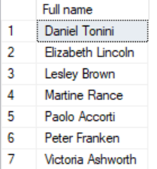

4.(4.sql) List all years and the number employees hired for each year, including the total number of employees hired by all publichers as below. /

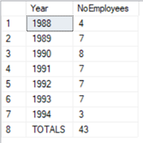

5.(5.sql) List all titles and the quantity sold for each title, including the total number sold as below. /

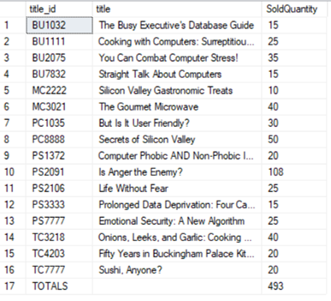

6.(6.sql) List titles that were published the most recently as below.

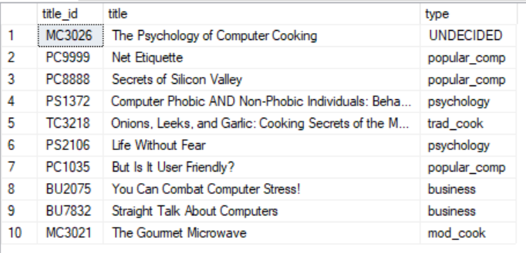

7.(7.sql) Find those pairs of publisher IDs that have the same number of employees. A pair should be listed only once, e.g., list (i, j), but not (j, i) as below.

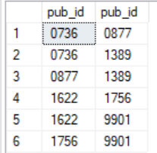

8.(8.sql) Find those titles that have the ytd_sales greater than of title 'Silicon Valley Gastronomic Treats' as below.

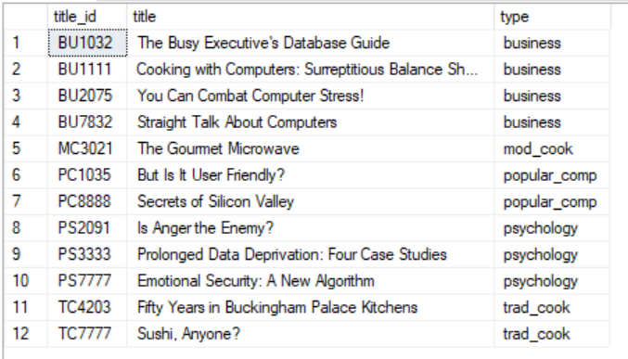

9.(9.sql) List total quantity, total amount of each title was sold by each store as below. /

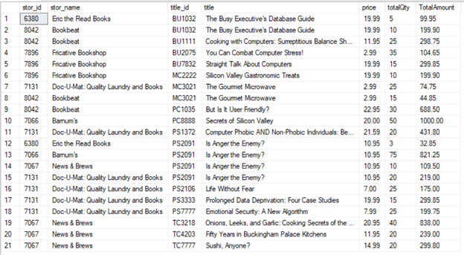

10.(10.sql) In Titles table, ytd_sales is the total amount of money since the point of sale for that title, and royalty is the total payment (in percentage) made by publisher to all authors of that title. If that total amount is divided equally for each author, list total year-to-date sales and the amounts due to each author by descending total sales and ascending author order as below. With the provided database instance, the result contains of 25 records. /

